Exploring the New York Neighborhoods For Housing

By: Kanchan Deopa

1. **Introduction**
   1. Background

The goal of the project was to develop a data driven strategy for finding out the best locality to find a new house in New York City using data provided by the NYC Open Data Website. Analyzing the population data, it became evident that density of people is varies with the neighborhoods.

The purpose of this report is as per the following:

1. To analyze and discuss the population distribution of different neighborhoods in New York.
2. To evaluate the different boroughs in New York city based on the air quality.
   1. Problem

Finding a new Home in a big and crowded city like New York can be overwhelming and very tiresome. Utilizing a tool that can provide an overview of different areas of New York city and prioritize the features required in locality for a good housing. This project aims to create a tool that will help people in getting the population distribution of the city to identify where the maximum people prefer to live and then check the basic facilities available in the area.

* 1. **Interest**

The New York city has an overall population of 8.623 million people. Housing such a large population and being the financial center of the world makes New York city one of the costliest cities as well. The housing is very expansive here and travelling to different places will also more expanses to user’s budget. If a person wants to change the location of housing that will be a further financial burden on that person. So, to find an optimum housing user can explore the initial areas using tis tool.

1. **Data**

2.1 Data Source

The data we will use in this project will be gathered from a variety of online sources.

The location information was found on this Wikipedia page. Its corresponding latitude and longitude were compiled manually using Nominatim.

will utilize a json file data < <https://catalog.data.gov/harvest/nyc-json> > to create a choropleth maps for population, which will also help in understanding the places better.

The venues data was found by using the Foursquare API.

2.2 **Exploratory Data Analysis**

After downloading the crime data (in CSV format) from the [NYC Open Data Website](https://nycopendata.socrata.com/) and cleaning the data is ready to use.

1. **Methodology**

3.1 Exploratory Data Analysis

The first exploratory data analysis I did was to create a choropleth and boundary map of the newyork city with boundary data obtained from NYC data website and the city population for 2010. First, we observe the population distribution for different borough.

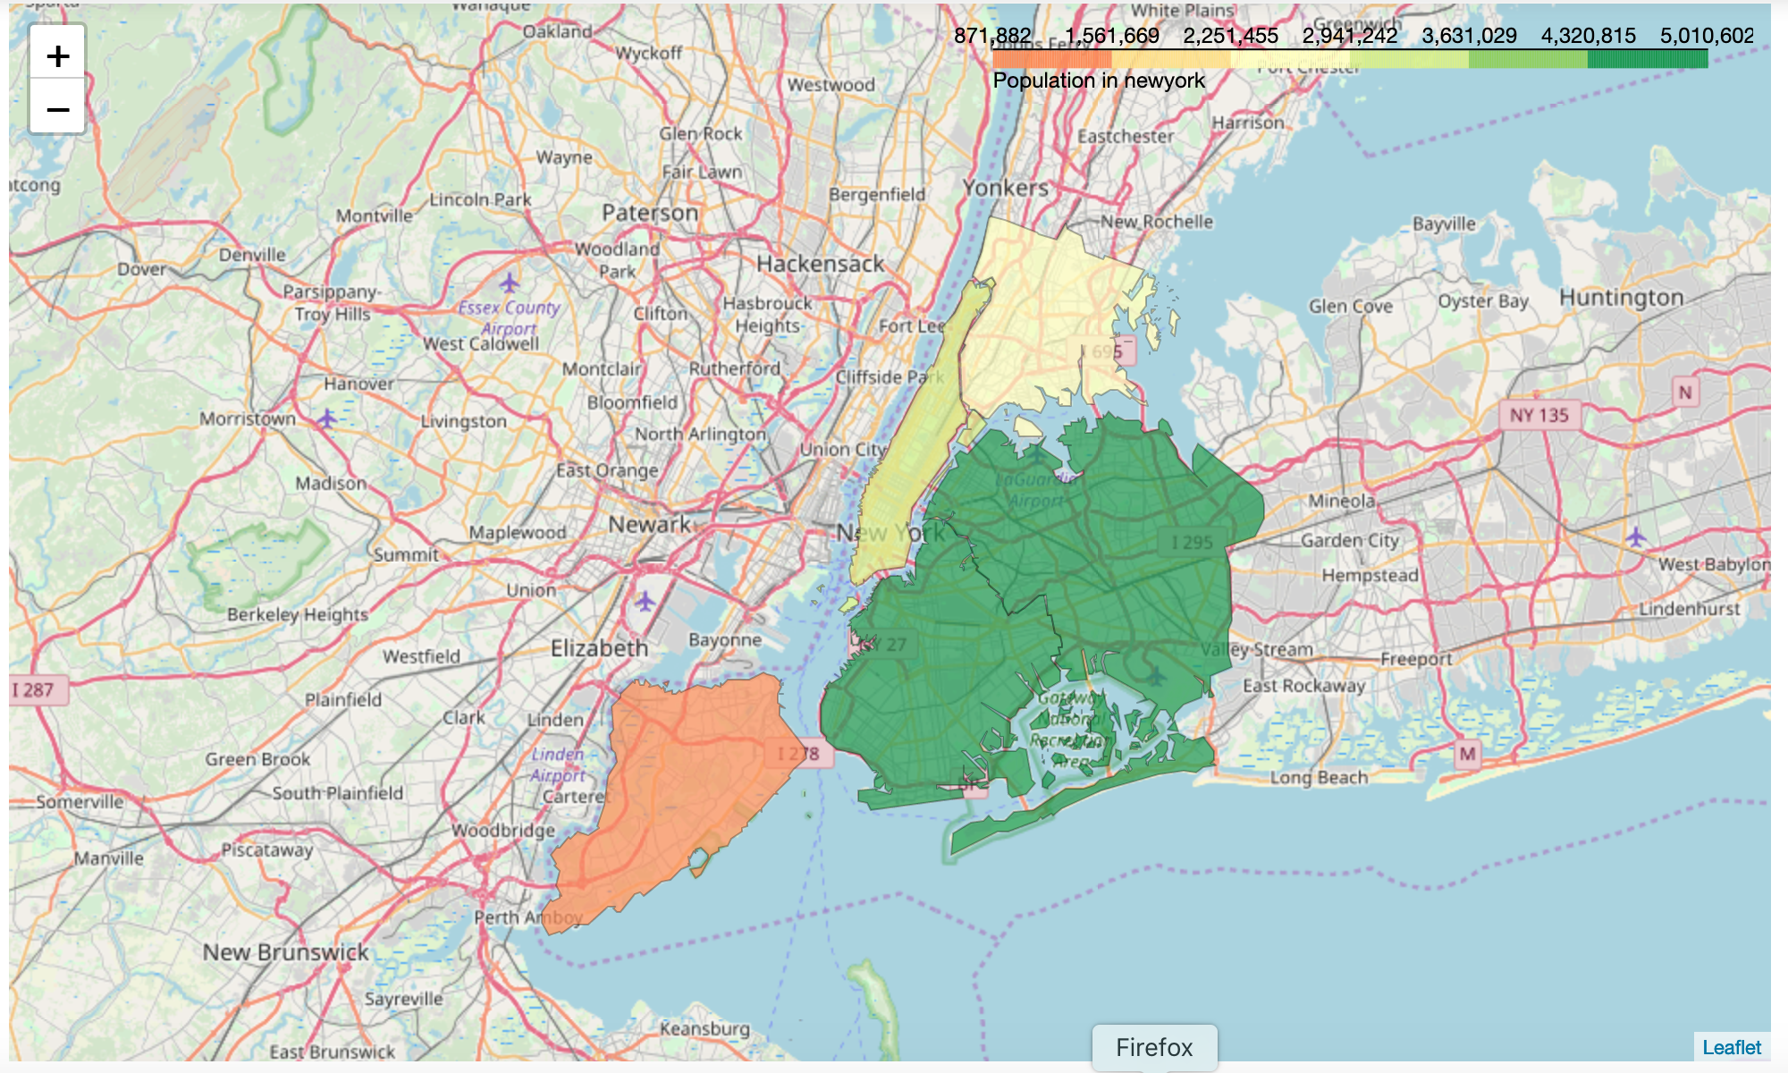

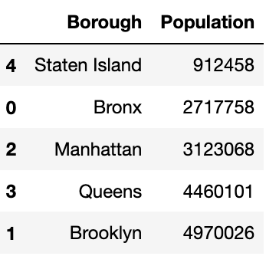

Next, I created the air quality distribution map all boroughs of new york city as shown below.

* Max toxins are present in Manhattan area
* Min toxin are present in Staten island

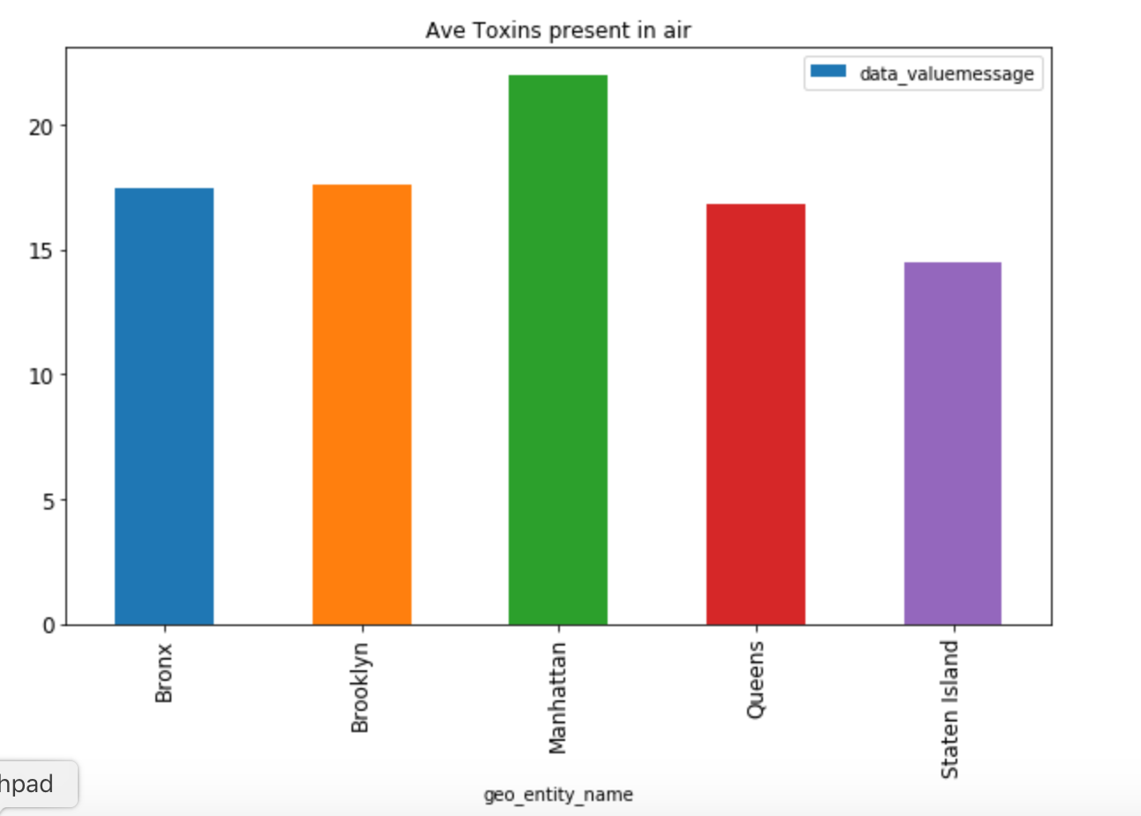

Based on the above visualization the user can select the borough he wants to look further

Population distribution of different neighborhoods in Manhattan is shown here.

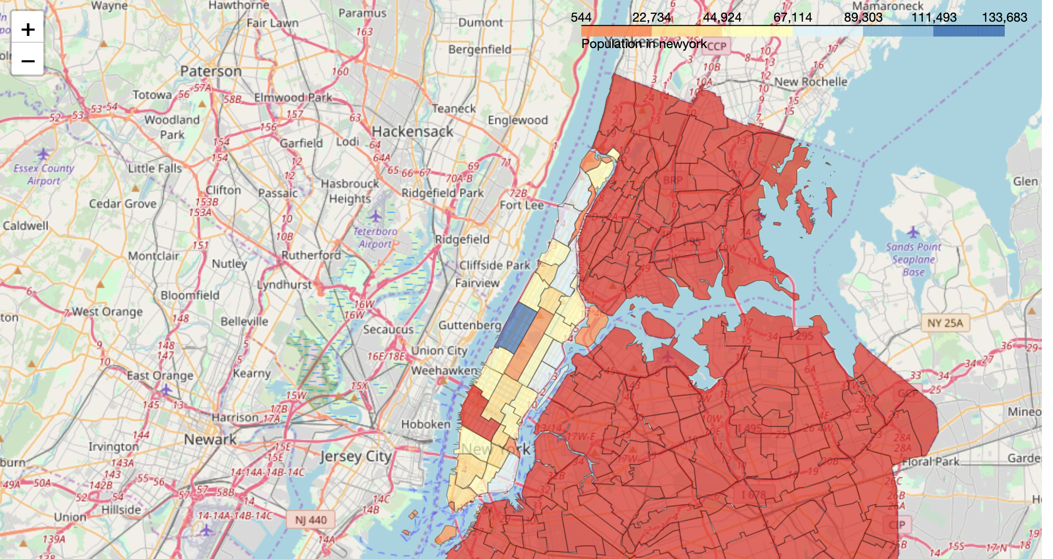

3.2 Clustering by Venues per neighborhood using Foursquare Data

Next, we downloaded venues data from Foursquare and clustered the venues and venue category by Neighborhood. We created the table below which shows the top 10 most common venues per neighborhood.

Cluster 0 shows parks, gym, theater and bakery etc. nearby venues. If a person is interested in these venues nearby he can further explore the particular neighborhood.

3.3 K-Means Clustering by neighborhood

We attempted to perform a K-Means clustering algorithm on the Neighborhood data and partition them into five different clusters to see if this machine learning algorithm could help us group the Neighborhoods into unique groups.

We also tried to use K-Means to perform clustering on the list of top New York landmarks.

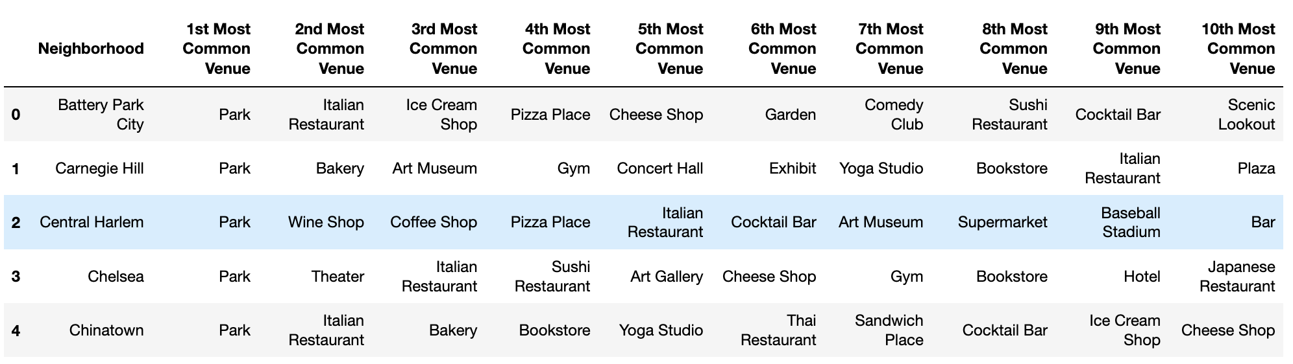

1. **Results /Visualizations**

The cluster can be visualized in the below snapshot

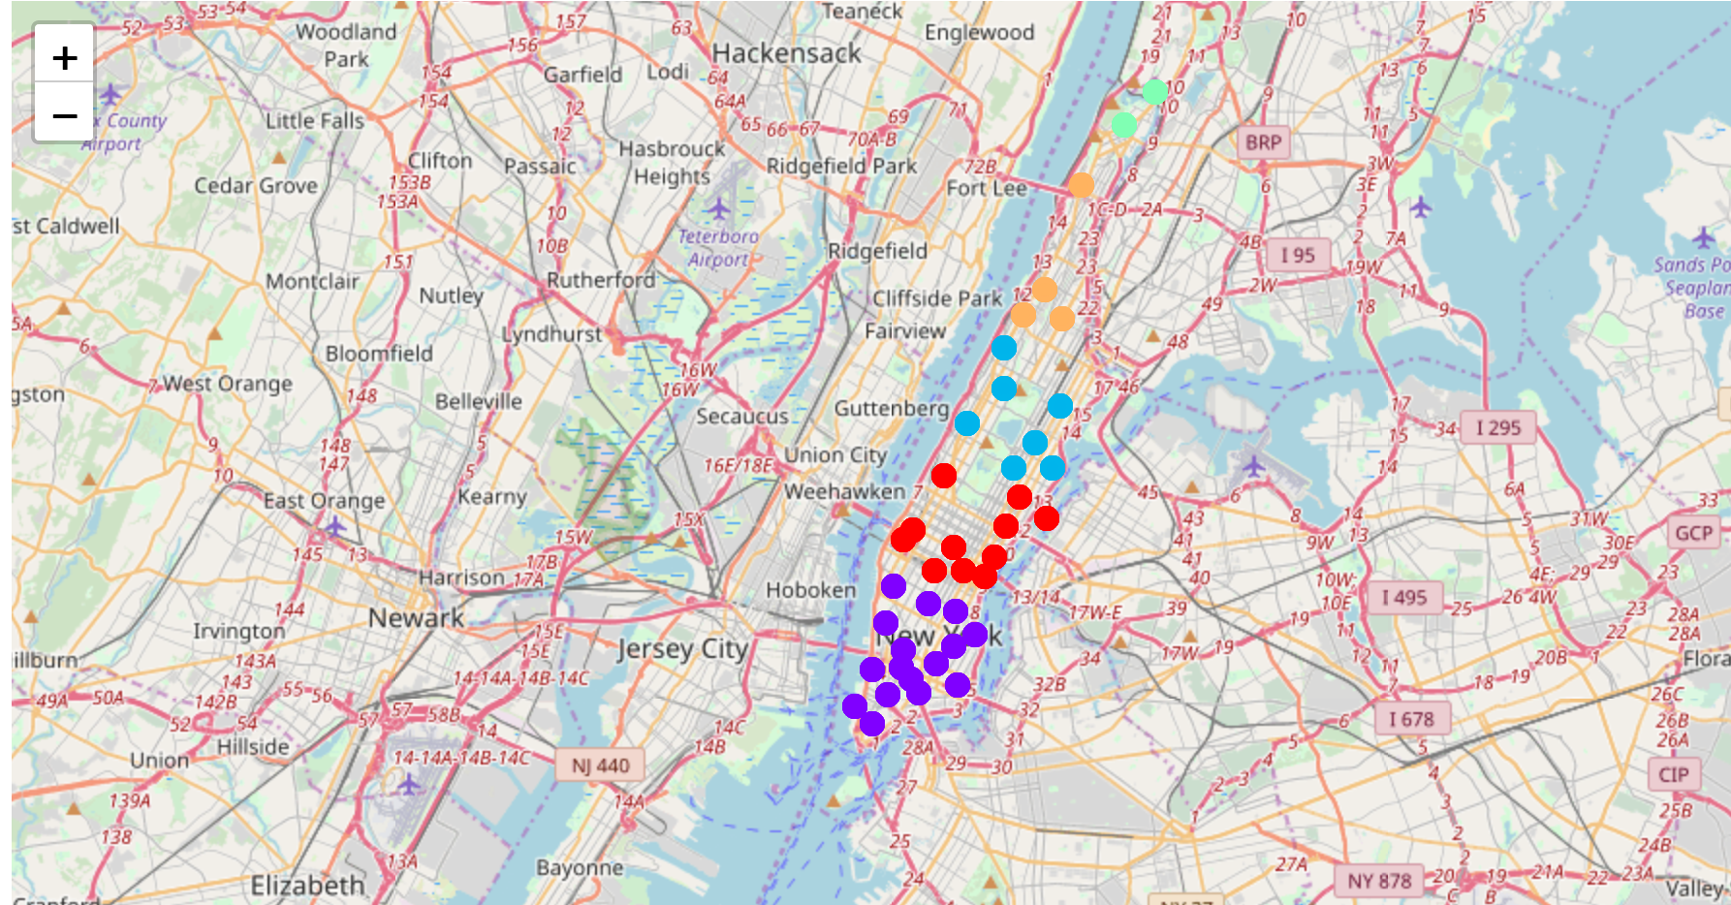

4.1 Hotel Accommodations

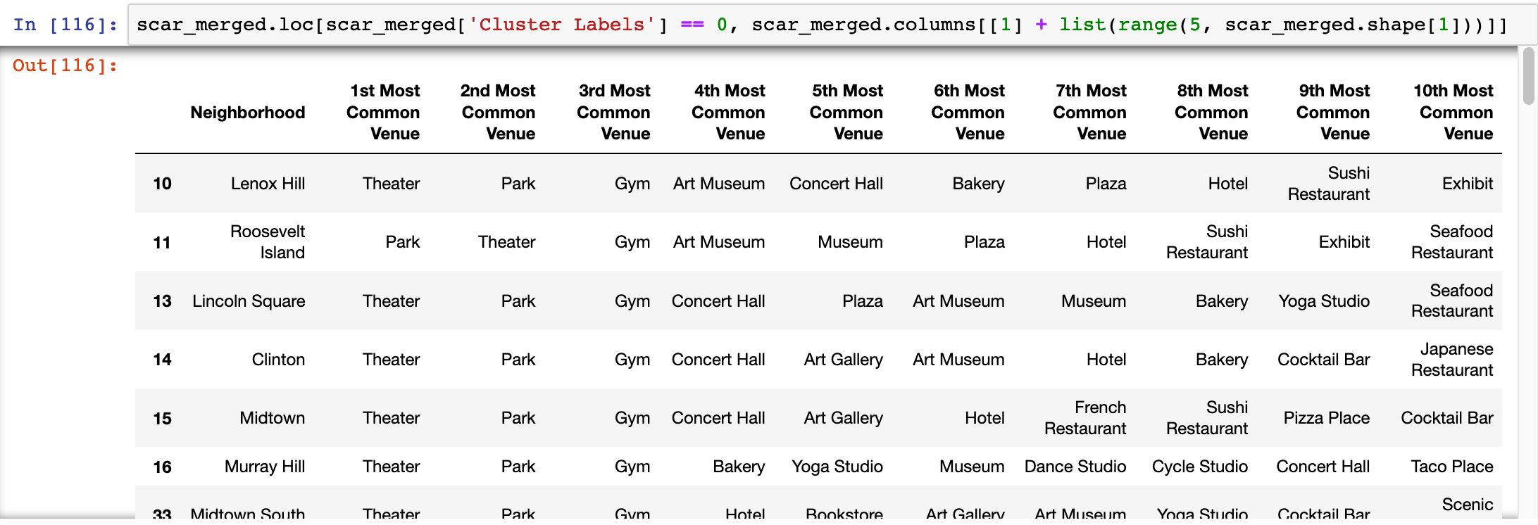

Best area to live is where cluster 0 is located.  
This is corroborated by population distribution map as well

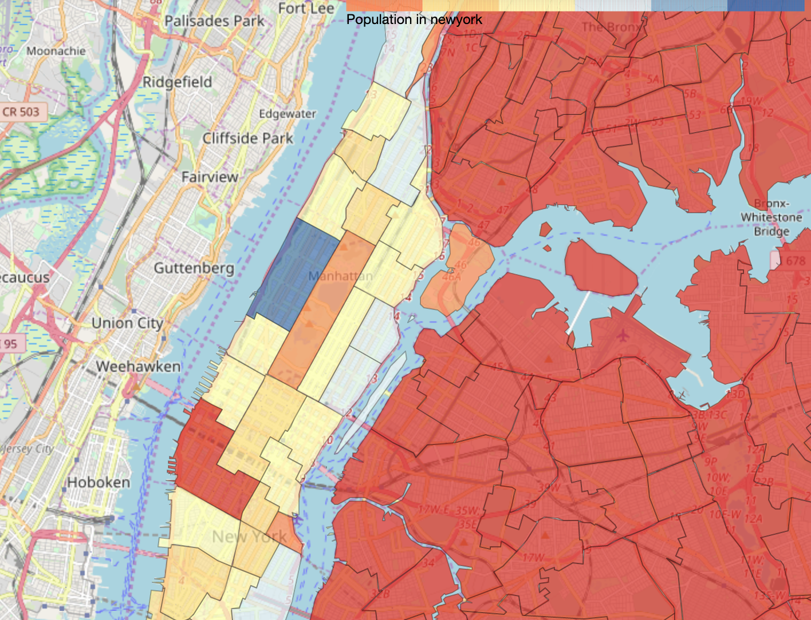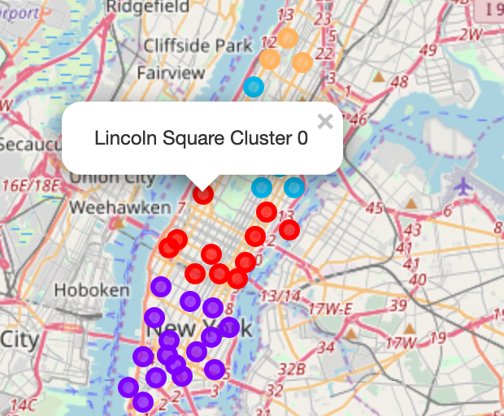

1. Discussion: based on user’s preference more such clusters can be created and if the user’s choice matches any cluster he can further investigate /explore those areas in neighborhood. To make this further useful more feature such as city crime data, average house price, Local transport availability and good school’s data can also be added to it.
2. Conclusion:

* This Analysis shows the process to select a housing area in New York.
* The maps help in finalizing a location with exploratory data analysis.

Further attributes can be added in the model to make it more customizable according to the need of future customers.